Relational Databases with MySQL Week 3 Coding Assignment
Points possible: 70
Category | Criteria | % of Grade
Functionality | Does the code work? | 25
Organization | Is the code clean and organized? Proper use of white space, syntax, and consistency are utilized. Names and comments are concise and clear. | 25
Creativity | Student solved the problems presented in the assignment using creativity and out of the box thinking. | 25
Completeness | All requirements of the assignment are complete. | 25

Instructions: Using a text editor of your choice, write the queries that accomplishes the objectives listed below. Take screenshots of the queries and results and paste them in this document where instructed below. Create a new repository on GitHub for this week’s assignments and push this document, with your Java project code, to the repository. Lastly, in the Learning Management System, click the “Add Submission” button and paste the URL to your GitHub repository.
Coding Steps:
You have been asked to create a database for a new social media application that your company is developing.
The database must store user data such as username, email, password, etc...
Users are able to post and comment. So, your database must also store post and comment data.
We need to know which user made which posts.
We also need to know which user made which comments, and which post a comment is on.
Posts and comments should both include the time they were created, and what the content of the post or comment is.

Create an Entity Relationship Diagram (ERD) using draw.io to model the database you will create. Insert a screenshot of the ERD in the screenshots section below.
Write a SQL script to create the database. Insert a screenshot of the SQL in your script.

Hints:
You will only need three tables.
Two tables will have foreign key references.
One table will have two foreign key references.
Screenshots:
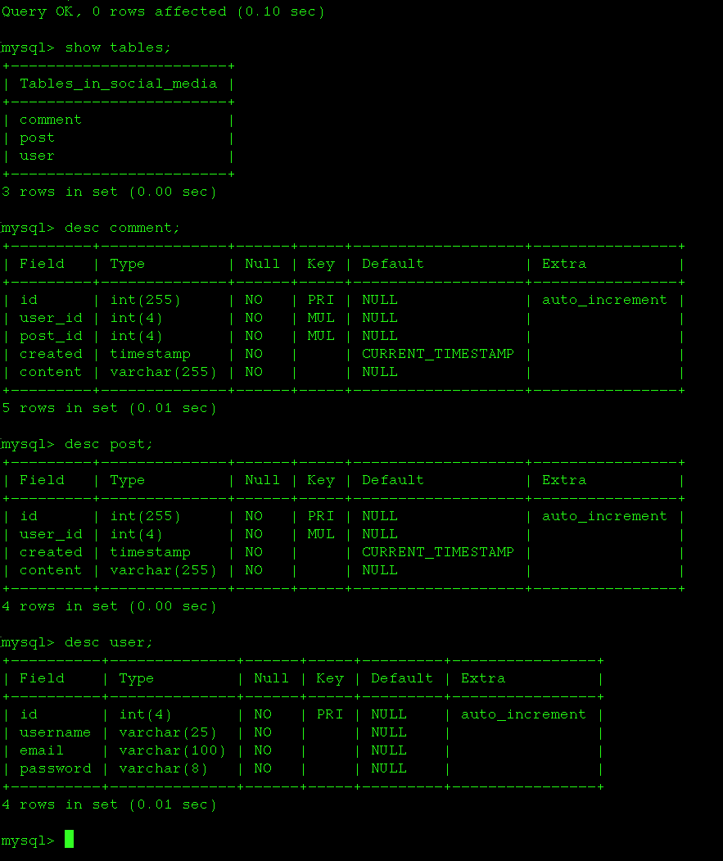

URL to GitHub Repository:https://github.com/CharliePaz20/wk3sql.git

